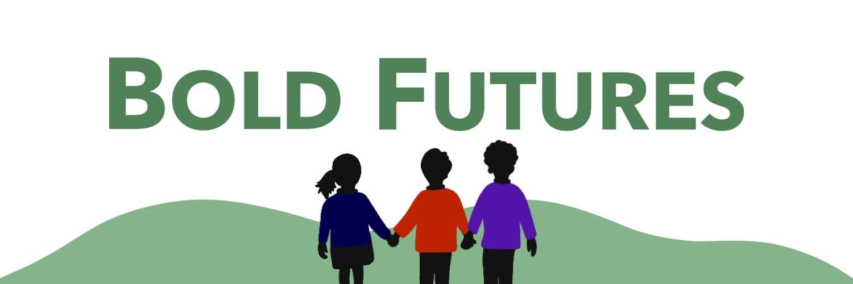

Bold Futures Federation
GOVERNOR VISITS TO SCHOOL POLICY

Policy First Introduced:

Latest Review: February 2025

Signed:_________________________ (Policy Owner)

Print Name:_____________________

Review Date:____________________

Signed:_________________________ (Governor Approval)

Print Name:_____________________

Approval Date:___________________

GOVERNOR VISITS TO SCHOOL POLICY

Governing bodies have a statutory responsibility to monitor and evaluate the effectiveness of the schools and their curriculum. We believe that visiting the schools is one of the ways in which this can be achieved.

Through our programme of governor visits in each school we aim:

- To recognise and celebrate success
- To develop good working relationships between staff and governors
- To improve governors’ knowledge of the school, the curriculum and its delivery
- To support governors in their roles of additional responsibility
- To assist the governing body in fulfilling its statutory roles
- To assist with understanding the effectiveness of the Strategic Improvement Plan and help identify priorities for future plans

Frequency and timing of visits
- Governors aim to make at least two formal visit per year linked to the SIP. Additional visits are actively encouraged and can be made by appointment with the Headteacher.
- Individual governors should arrange visits through the Headteacher giving at least a week’s notice for a formal visit of the intended visit. The intention of the visit should be shared and advised to the class teacher.
- Each visit should have an identified focus as identified by the school strategic plan or a committee annual planner or an event.
- All new governors will be offered an introductory visit soon after their appointment to the governing body as part of their induction process.
- Governors will receive a copy of the school newsletter, which contains notice of events and governors are encouraged to attend so that all events have a governor representative.
- Governors should prepare for the visit and have researched the focus area.
- Governors may take notes during the visit but these should be destroyed following production of the formal report. No personal details should be included in the report (e.g. names of children).
- Following visits informal feedback will be given to the Headteacher or Head of School, following which a formal visit report will be passed to the Headteacher.
- All governors should sign in each time that a visit is made and wear a Governor name badge.

Format for visits
- The visit should be arranged through the Headteacher and governors must give at least one weeks’ notice. School Improvement Visits will be planned throughout the year ( 2 per year to be attended) Times for arrival and feedback will be decided.
- At the start of a visit the class teacher will explain to the governor what activities are taking place, what the governor is expected to do, and the teaching and learning objectives for the session. Governors will be aware of the confidentiality of what they hear and see and will not disrupt the lesson in progress.
- The Headteacher will meet with the governor to review the focus of the visit and clarify any queries. Areas of concern will not be raised with the class teacher.
- The governor will complete a Visits report and forward as soon as possible to the Headteacher.

When governors visit classrooms, it is not appropriate to:

- Make judgements about the quality of teaching
- Check on the progress of their own children
- Pursue personal agendas
- Monopolise the teacher’s time
- Arrive with inflexible pre-conceived ideas.

Monitoring the effectiveness of the policy
The Headteacher will consult with staff to consider the effectiveness and success of the visits and report back to the FGB in the Head teacher’s report.

At the beginning of each academic year governors will agree a programme of visits with foci based upon the School Improvement Plan, requirements for evidence for the SEF and to monitor the progress of particular projects. At the end of the academic year this will be reviewed to confirm that all areas have been covered and to discuss the effectiveness of the visits themselves.

Signed:_____________________ (Chair of Governors) Date:______

Policy Date : February 2025
Next review: As needed

